Cypress Containerization
FROM cypress/included:cypress-12.5.0-node-16.18.1-chrome-109.0.5414.74-1-ff-109.0-edge-109.0.1518.52-1
WORKDIR /app
COPY package.json /app
COPY package-lock.json /app
RUN npm install --force
RUN npm install @reportportal/agent-js-cypress ----legacy-peer-deps
COPY . /app
RUN apt-get install -y xvfb
RUN apt-get update
CMD [ "npx", "cypress" , "run" ]

Current custom cypress docker image – cyder:1.6 with latest test-suite files
(Refer Jenkins pipeline documented.pdf -> containerizing & hosting temporary env section to understand test env configurations done in repo)

Build this cypress image by copying test-suite files into /app directory of container and run the following commands to run containerized cypress tests:
sudo docker run cyder:1.6 npx cypress run --env ENV='test',TAGS='@smoketest' --spec '**/**/login.feature'
sudo docker run cyder:1.6 npx cypress run --env ENV='test',TAGS='@smoke' --spec '**/**/header.feature'
sudo docker run cyder:1.6 npx cypress run --env ENV='test',TAGS='@smoke' --spec '**/**/footer.feature'
Dockerized Cypress test with @smoketest tag output sample:
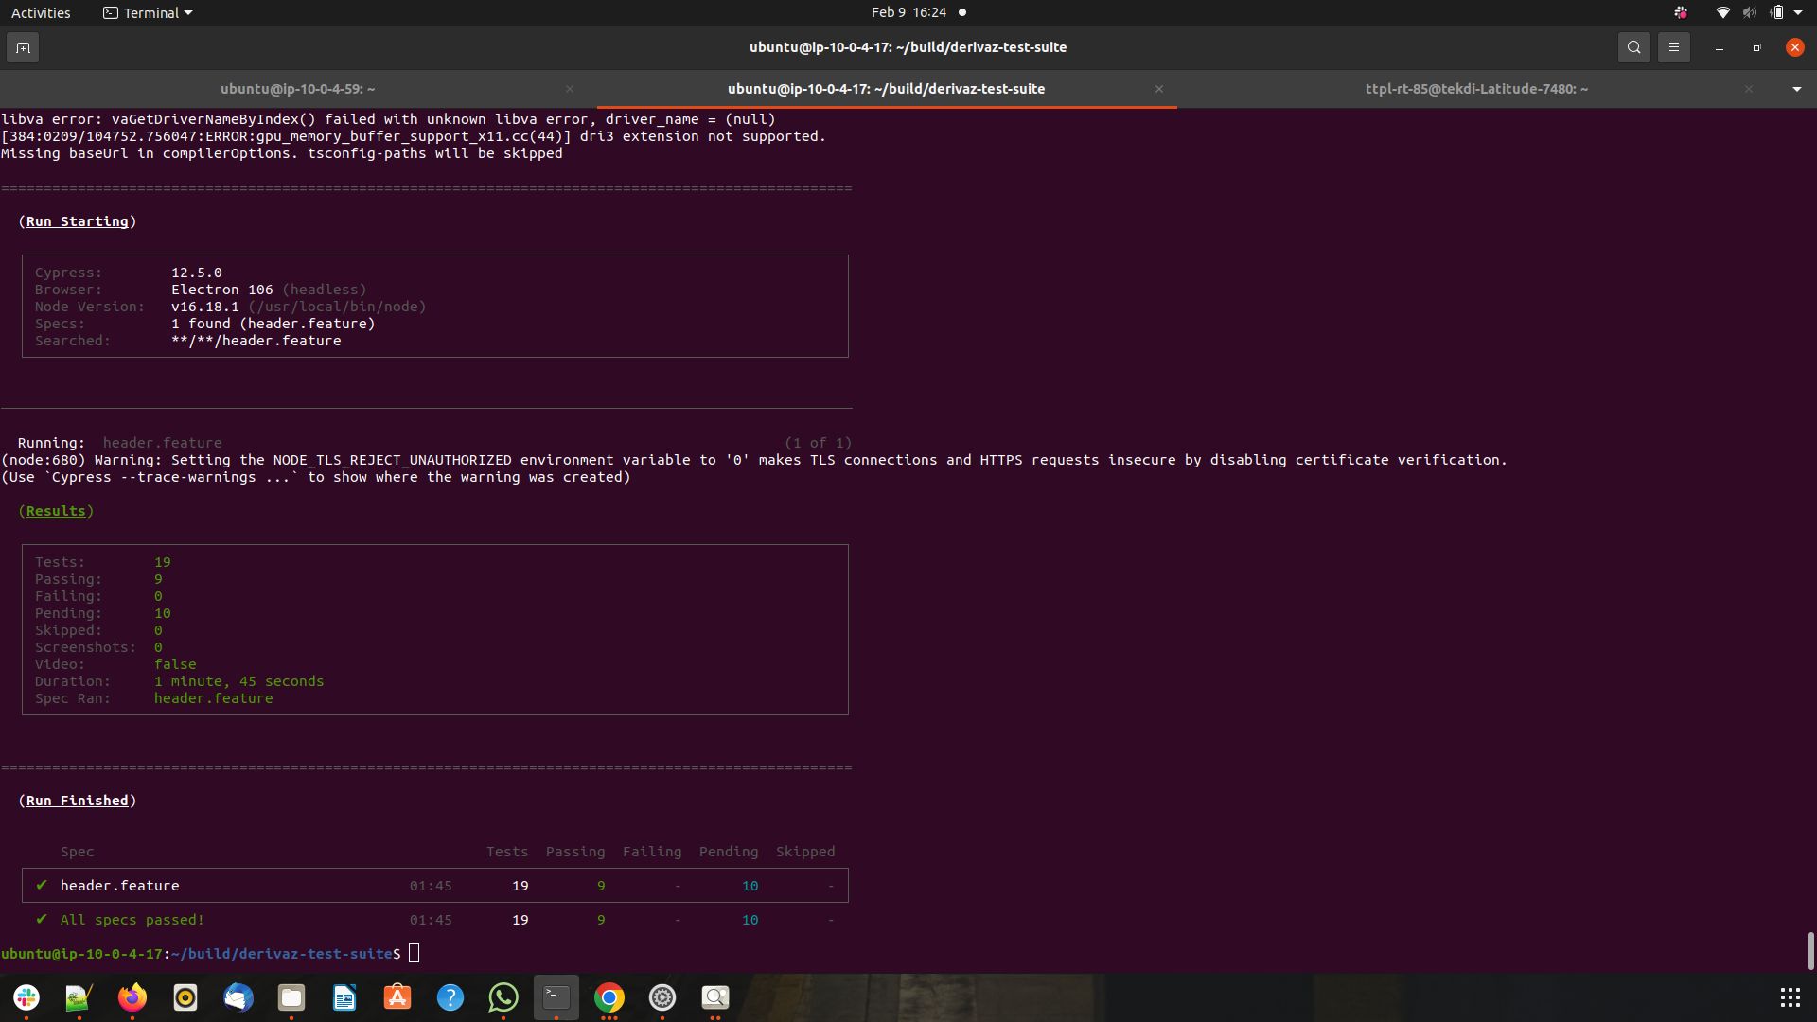
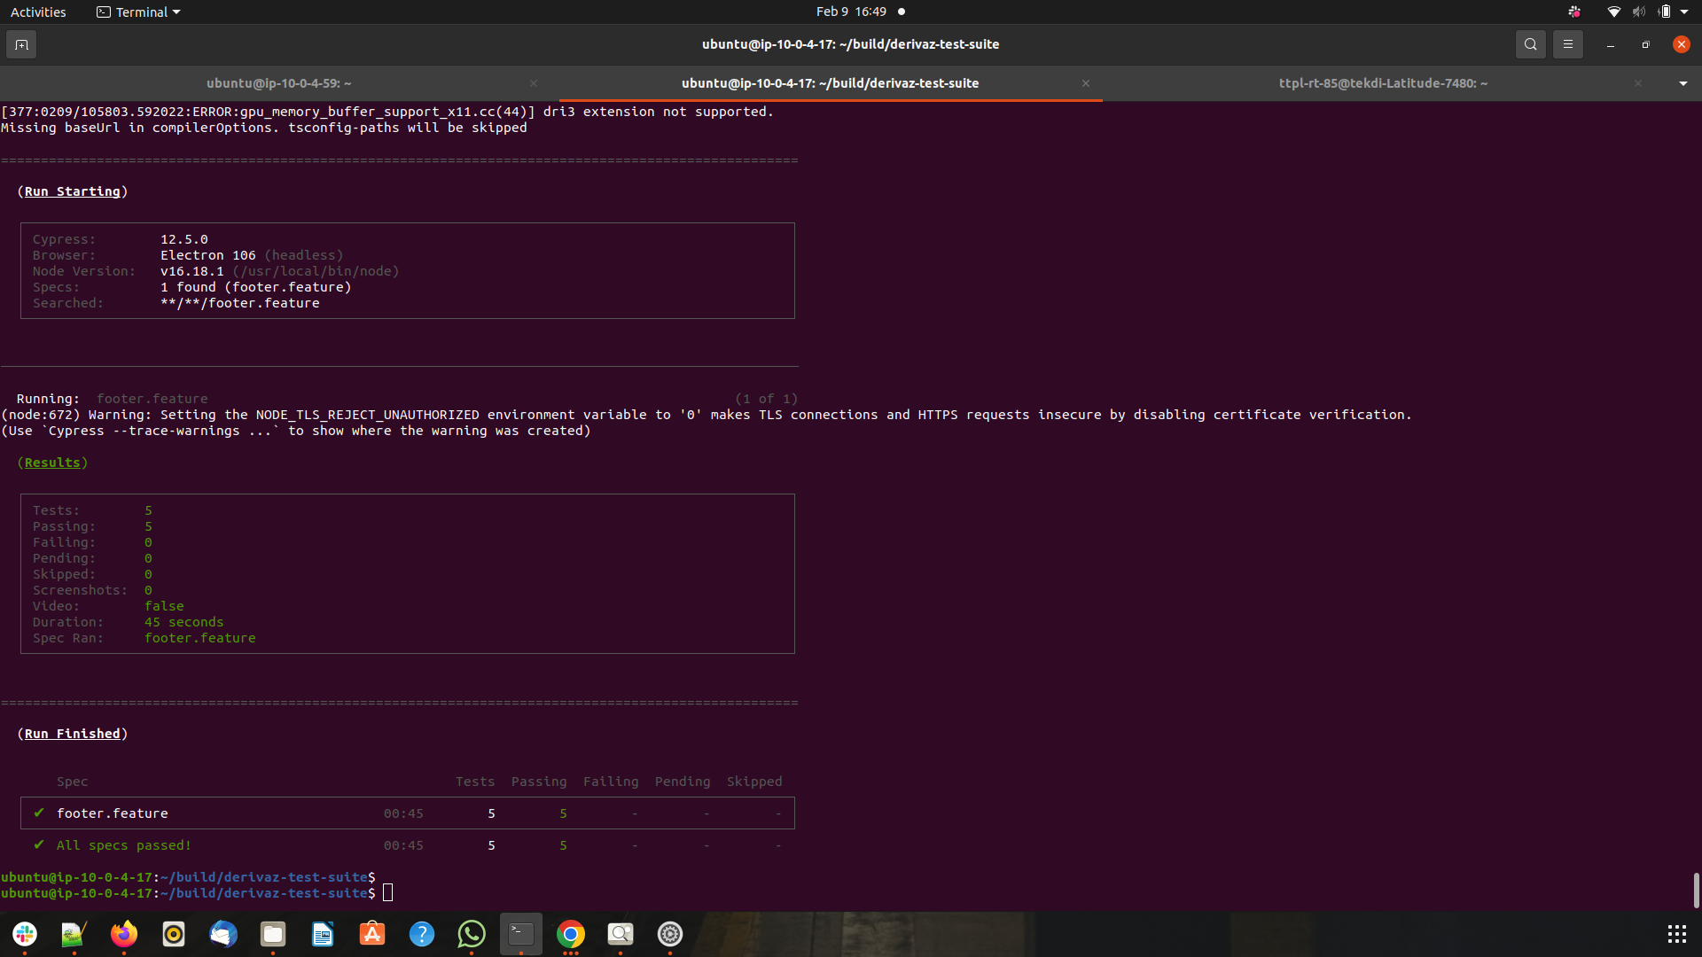
header.feature & footer.feature

